Assignment 2

**COMSATS University Islamabad**

Sahiwal Campus



**Alina Raza**

FA17-BS(CS)-072-B

**Dr. Farrukh** Bioinformatics July 8, 2020

# Question 1:

## What is difference between peptides and proteins?

Proteins and peptides are fundamental components of cells that carry out important biological functions. Proteins give cells their shape. They respond to signals transmitted from the extracellular environment. Certain types of peptides play key roles in regulating the activities of other molecules. Structurally, proteins and peptides are very similar, being made up of chains of amino acids that are held together by peptide bonds. A peptide is found in every cell and tissue of the body. It is an essential cellular component and forms a wide range of functions. It is made up of a short chain of amino acids. Usually, the chain includes two or more amino acids. peptide is two or more amino acids joined together by peptide bonds Therefore, proteins are long chains of amino acids held together by peptide bonds.

* A polypeptide is a simple polymer of amino-acids linked by covalent peptide bonds, while a protein is a complex molecule characterized by a stable structure composed by the folding of one or more polypeptide chains, held together by non-covalent bonds.
* A polypeptide’s main function is being the primary structure of a protein, while a protein is a complex compound, with ligand-binding sites enabling it to bind to specific and different molecules and be functionally active in the cell.
* Polypeptides and proteins are naturally occurring and essential organic compounds of a cell. While amino-acids are their common primary component, polypeptides and proteins present major structural and functional differences

# Question 2:

## Find one example of each four domains?

* **α-helix**

Cytochrome c is an example of alpha helix domain. Cytochrome c belongs to class I of the c-type cytochrome family. The protein backbone is folded into five α-helices that are numbered α1-α5 from N-terminus to C-terminus. Helices α3, α4 and α5 are referred to as 50s, 60s and 70s helix respectively when referring to mitochondrial cytochrome c.

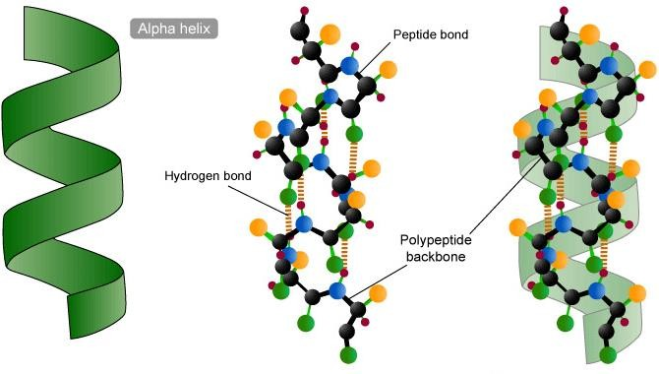

## α α helix:

Tropomyosin are a large family of integral components of actin filaments that play a critical role in regulating the function of actin filaments in both muscle and non-muscle cells. These proteins consist of rod-shaped coiled-coil hetero- or homo-dimers that lie along the α-helical groove of most actin filaments. Interaction occurs along the length of the actin filament, with dimers aligning in a head-to-tail fashion.

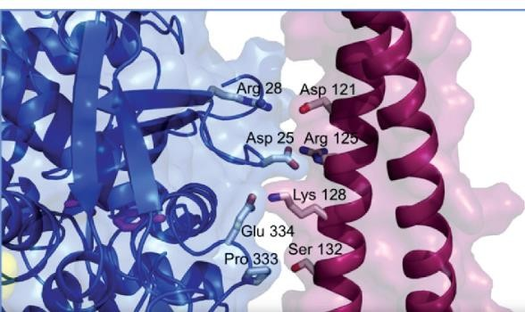

## 4 helix bundle:

A number of cytokines consist of four alpha-helices such as Interleukin-2 and human Growth Hormone.

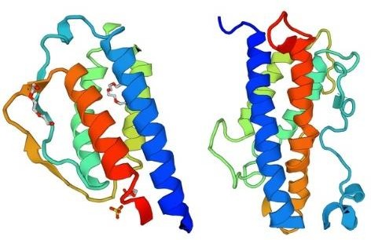

## 8α helix:

Neuroglobin is a member of the vertebrate globin family involved in cellular oxygen homeostasis. It is an intracellular hemoprotein expressed in the central and peripheral nervous system, cerebrospinal fluid, retina and endocrine tissues. Neuroglobin is a monomer that reversibly binds oxygen with an affinity higher than that of hemoglobin.

